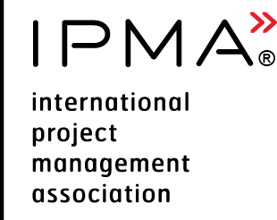 | Executive Summary Report  for IPMA Level A or B candidate, Programme Management

Please consider the environment before printing this document

Purpose
The purpose of this document is to provide direction on how to prepare the executive summary report for IPMA level A or B candidates working in programme management.
Candidate name
Level applied for (check one) | IPMA Level A | IPMA Level B
Description of employer’s organisation
Organisation name:
Number of employees | < 250 | 250 – 5000 | > 5000
Main sector organisation operates in | E.g. software development, banking
Sector in which the portfolio operates
Role of applicant within employer’s organisation
An organisational chart with applicant’s position identified
Area(s) of responsibility
An overview of the programme management processes/procedures used

Summary for all programmes
Name of the programme | Programme start date | Programme finish date | Duration (months)
Programme #1
Programme #2
Programme #3

Add more lines if applicable

Summary of programme #1
Strategical benefit of the programme for the organisation | Describe the main benefits and deliverables of the programme.
Time period of programme and projects within programme | Programme time period: xx.xx.xxxx - xx.xx.xxxx  Project 1 xx.xx.xxxx - xx.xx.xxxx  Project 2 xx.xx.xxxx - xx.xx.xxxx  Project 3 xx.xx.xxxx - xx.xx.xxxx  Project 4 xx.xx.xxxx - xx.xx.xxxx  Project 5 xx.xx.xxxx - xx.xx.xxxx
Management effort | Total number of menmonths of execution.
Total budget
Resources available | Personnel:  - Number of persons involved into programme management  - Number of persons total (peak) in the projects  - Number of persons reporting to you
Contractors | - Number of contractors  - Number of subcontractors
Stakeholders | Relationship with internal and external stakeholders.
Description of programme management | Describe the programme management organisation.  Describe the methods, tools, techniques and documents used.
Description of programme challenges | Describe how you have managed the programme and how you met the complexity criteria. You can use the STAR approach (Situation, Task, Action, Result) in order to structure the report.  - Situation/challenge  - Effort to deal with it  - Outcome  - Reference to competence elements  You can include the links to the information in complexity criteria form.

Please copy and fill in relevant parts of this report accordingly to cover your experience.

