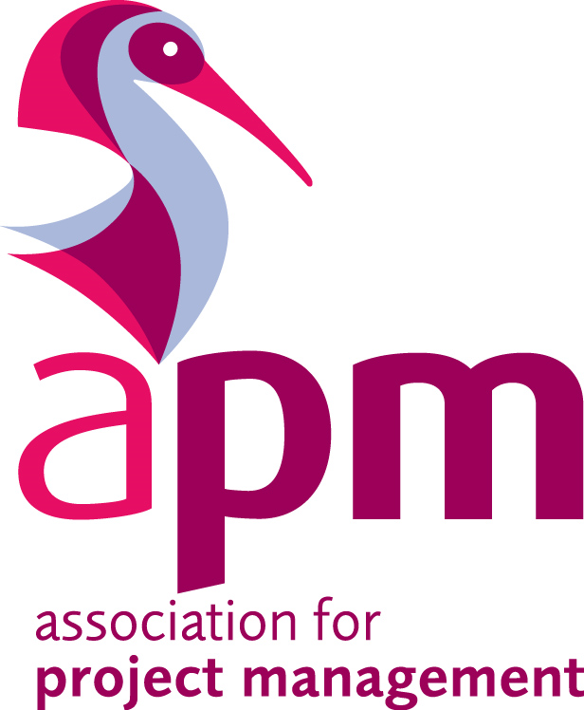
PM Challenge 2016/17

Competition Overview
APM Thames Valley Branch

About the PM Challenge
The Thames Valley Project Management Challenge is an annual competition for developing project management professionals.
The challenge aims to improve the competitors’ project management skills in a real life environment with the support of a mentor from within their organisations. It is run over a number of months and culminates in a prestigious finals night. The objectives and benefits of the challenge are further detailed within this information pack.

Introduction to the APM
The award winning Association for Project Management is committed to developing and promoting project and programme management through its Five Dimensions of Professionalism. There are a number of ways in which you and your career in project management can benefit from what the APM does, including:-
- membership
- qualifications
- events
- publications
- online services
The association is a registered charity with over 21,000 individual and 550 corporate members making it the largest professional body of its kind in Europe. As part of its strategy to raise awareness of standards in the profession it is currently in the process of applying for a Royal Charter.
Strategy 2020
Our vision for the profession is ambitious, challenging and radical. Above all, it reflects what society expects: A world in which all projects succeed.
APM’s mission is: To provide leadership to the movement of committed organisations and individuals who share our passion for improving project outcomes.
We lead activities that deliver benefit:
- For individuals; by developing the leadership capability of all those impacting on project success through globally recognised professional qualifications and certifications.
- For organisations; by enhancing organisational capacity to deliver successful change through accredited standards of management practice.
- For society; by investing in the creation and dissemination of valuable knowledge in the management of projects and driving its effective application.

Five Dimensions of Professionalism
The Association for Project Management supports professional values. The FIVE Dimensions of Professionalism provide a framework that helps you develop your career. www.apm.org.uk/APM5Dimensions.
Project professionals make a direct contribution to the economy, environment and society by managing effective change. They are capable, accountable and committed to their profession working in all sectors and all types of projects and programmes. They experience unprecedented variety and a track-record of achievement; this provides project professionals with the benefits of exceptional job satisfaction, professional status and other rewards.

Project professionals are able to demonstrate the APM five dimensions of professionalism:
- Breadth

The APM Body of Knowledge defines the knowledge needed to manage any kind of project. It underpins many project management standards and methods including the National Occupational Standards in Project Management.

- Depth
The APM Competence Framework provides a guide to project management competences. It is part of your professional toolkit; mapping levels of knowledge and experience to help you progress your skills and abilities.

- Achievement
APM qualifications take your career in new and exciting directions. They are recognised across the profession and aligned with IPMA’s 4 level Certification Program.

- Commitment
Continuing Professional Development helps develop your project management practice. A targeted development plan will enhance your project management career.

- Accountability
The APM Code of Professional Conduct outlines the ethical practice expected of a professional. Becoming an APM member shows your commitment to the Code and sets you apart from others.

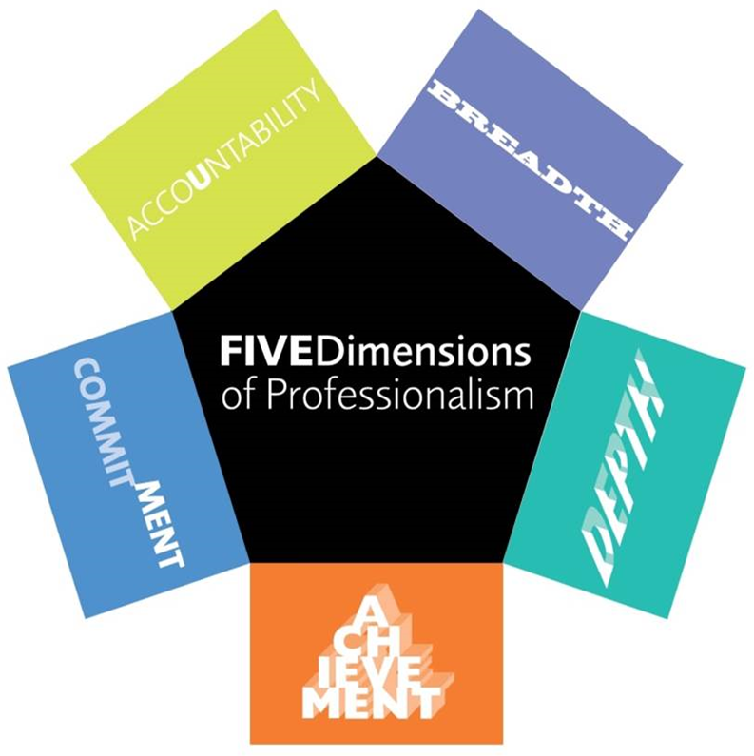

Body of Knowledge
The APM Body of Knowledge (BoK) defines the breadth of the project, programme and portfolio management profession. It makes up one of the FIVE Dimensions of Professionalism.
The APM Body of Knowledge definitions can be found on the APM Knowledge site (knowledge.apm.org.uk) broken down into the 69 topic areas which are contained in the full text. Topics are divided over four sections; context, people, delivery, and interfaces.

APM Competence Framework
The new APM Competence Framework 2nd edition, released in June 2015, describes APM's view of the competences necessary for effective project, programme, portfolio management and PMO in today's environment and in our view of the future needs of the profession.
The Number of competences have been streamlined from 47 to 27, removing duplication and the scope extended to cover more roles including project management, programme management, portfolio management and PMO.
During the TVB Project Management Challenge, the expectation of the Project Board (Judges) is that teams will utilise elements of both the APM BoK and the APM Competence Framework.

For further information on APM please visit the visit the APM website www.apm.org.uk

PM Challenge Objectives & Benefits
The prime objectives of the Thames Valley Branch PM Challenge are to deliver a range of professional learning benefits to individual team members as well as corporate participants. The challenge is open to new entrants to the project management profession and students of project management and the key objectives of the competition are to provide participants with:
- The opportunity to gain early career recognition
- An excellent opportunity to develop and practice project management in a practical and competitive environment
- A benchmark of knowledge, understanding and capability against peers
- The opportunity to be mentored
- Attendance at an award ceremony in recognition of their project
Benefits of the scheme include:
- A structure where entrants are challenged in a friendly yet competitive environment
- Use of project management methods to plan, implement and deliver a successful project
- Evidence project management theory and skills on a real project
- Experience real life hard and soft project management skills
- Develop an understanding of success criteria required to deliver a winning project
- Develop the qualities needed to become an effective and successful Project Manager
- To gain a unique addition to your CV
- Networking opportunities

Project Theme
Given the challenges facing the UK and the project management profession as we prepare to exit the European Union, the themes to choose from for this year’s (2016-17) PM Challenge are: Innovation or Collaboration.

Past Winners
Last year’s theme was Sustainability and our winners of the 2015/16 PM Challenge were:
Team Sustainabili-tree of Nationwide
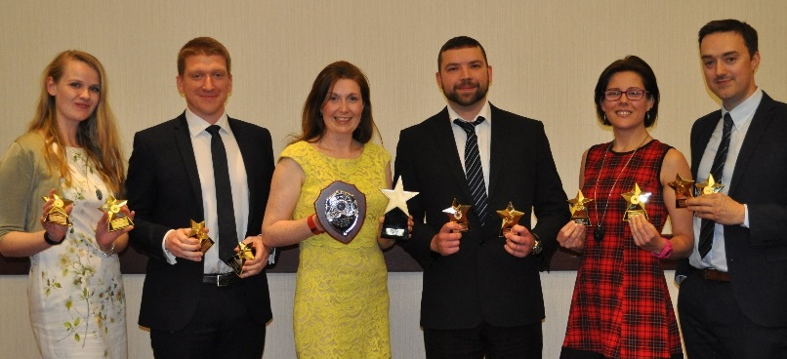
And Team STARS of Thales for the poster competition
The PM Challenge Rules
Terms of Reference
- Each team will be required to undertake a project on the theme of Innovation or Collaboration. The choice of project is up to each team, however, teams should ensure they focus on the theme throughout the project lifecycle.
- PM Challenge consists of 4 Phases and teams should refer to the timeline/schedule on page 10.
- Teams will be required to submit the following:
  - An entry form
  - Project proposal
  - Interim report
  - Progress report
  - Final report
- Project Proposals will be reviewed by the Project Board and teams informed of their successful entry in to the competition.
- Teams should consider the format of any documents submitted to the Project Board, with specific consideration being given to content, layout and readability.
- Each Report will have an overall % marking during the PM Challenge.
- The marks obtained for the Reports will be used by the Project Board to determine which 4 teams are selected to present at the Finals Night.
- Each of the finalist teams will be required to prepare and deliver a 10-minute presentation which will be followed by up to 5 minutes of questions from the Project Board and APM Members.
- There will be prizes for:
  - The best presentation as judged by the audience on the night of the awards ceremony
  - The best overall project – based on points awarded during the PM Challenge
- All Teams who are not presenting at the Finals Night will present a poster on the same night that will judged separately with its own prize.
- Each team will be required to participate in the Finals Night Phase of the competition.
- Each team will be required to submit a PM Challenge entry fee of £500 with their interim report to cover administration and the cost of a table at the Finals Night awards ceremony.
- Teams that do not submit the entry fee will not go on to the next stage of the challenge.
- Teams will require the support of a mentor and they should be provided by the sponsoring organisation.
- Funding for project delivery will not be available from APM and should be provided by the organisation sponsoring the team.
PM Challenge Rules
- Teams must abide by the rules of the competition.
- Each team is to identify and develop a project of their choice relating to the theme.
- The sponsoring business or HEI should be geographically based in the Thames Valley region or have a formal organisational body registered in the region – entries from organisations outside the Thames Valley region will be considered on an individual basis.
- Corporate entries should be limited to teams comprising apprentices, graduates or trainees with up to three years’ full or part time employment, or new employees with less than three years’ experience in the project management profession.
- Student entries must be enrolled and attending a course at the University at the time of the challenge.
- Teams should comprise of a minimum three and maximum six members per team.
- Each phase of the project must be completed by the relevant date (refer to Key Dates schedule).
- Project Proposals should be submitted using the template provided (maximum of 4 pages) and consist of the full project lifecycle.
- The Interim Report must:
  - Be submitted by the milestone date
  - Consist of 3,000 words maximum
  - Communicate the status of the project and forecasts to completion
  - Include work completed and work planned
  - Include any changes to the original plan/proposition and risk assessment
  - Explain any necessary recovery actions to meet the planned objectives
- The Progress Report:
  - Will be required half way through the project implementation/delivery phase and should consist of up to 500 words and 4 pages’ maximum
  - Is not part of the competitive judging, but it will be used by the Project Board to assist with the selection of teams going through to the Final Phase
- The Final Report:
  - Must be submitted by the milestone date
  - Consist of up to 7,000 words and a maximum of 20 pages, excluding title page, table of contents, management summary and appendices
  - The report should provide details on the positives and negatives from the execution of the core project components and evidence of the lessons learnt that the team will take forward.
  - Will be used by the Project Board to select which teams will go through to the Finals Night and will be taken into consideration in determining the winner(s)
  - In the event of any teams obtaining the same marks at the end of Phase 3, team Progress Reports will be taken in to consideration
- The format of the Finals Night presentation is entirely up to the teams who reach that phase of the PM Challenge, but the presentation must be within the following constraints:
  - Presentation media will be via MS PowerPoint, Prezi or similar.
  - Animations are allowed but not videos
  - The use of pictures, diagrams and supporting documents is encouraged. These may be displayed at the team’s table for the Review Board and other attendees to inspect.
  - APM will provide a computer to use for the presentations. The specification of the software version installed will be provided nearer the date. The PC will be standalone so all files needed for the presentation will have to be held on a single portable storage device.
- Teams presenting at the Finals Night are expected to:
  - Focus their efforts on the content of the presentations, not on the ‘packaging’
  - Ensure that any supporting documents are printed appropriately – the expected quality is for these to be printed on a standard laser or ink jet printer
  - Include a Lessons Learnt Log
- Teams not presenting at the Finals Night will be required to present a poster to be judged on Finals Night in a separate competition.
- Each qualifying team must have a mentor:
  - Each team must interface with their mentor, who should be an experienced Project Manager
  - Where there are concerns about the competition, teams should communicate with the mentor in the first instance
- All budget expenditure must be accounted for and limited to a maximum of £500 per team, with funding provided by the sponsoring organisation.
- Project expenditure must be managed within the agreed budget.
- All resource costs must be accounted for and documented, including a summary submission within the Final Report.
- Supporting resources from outside the core team should be proportionate, appropriately tailored and declared within the project reports.

Concerns about the competition should be communicated to the mentor in the first instance or raised with the TVB Volunteer Coordinator ryan.wilcox@apm.org.uk. Alternatively the APM TVB Project Manager for the PM Challenge can be contacted via pmchallenge@apm-thamesvalley.org.uk

Schedule & Phases
The 2016-17 PM Challenge will consist of 4 key phases and 10 milestones:
- Phase 1 Launch and entry form submission – APM TVB PM Challenge 2016/17 launched on the APM website and via email. Competition entries are to be submitted using the template provided.
- Phase 2 Submission of proposals – teams submit a robust Project Proposal using the template provided. The template will be sent to teams that have submitted an entry form.
Following notification, the qualifying teams will have approximately 4 months to complete their projects. During this period each project team should have a dedicated mentor provided to them by the sponsoring organisation. Each project team will gain the experience of their mentor through facilitation. The interface with your mentor is described within the roles and responsibilities section.

- Phase 3 Project Delivery – teams work (with support from their mentor) to successfully deliver their project, and will provide an Interim Report, Progress Report and Final Report which are to be presented to the TVB Project Board by the dates prescribed in the milestone programme schedule.
- Phase 4 Finals Night – the finalist teams present their projects and the winning team is selected and prizes awarded.
The Board will be made up of APM Members and TVB Committee Members, who will review all proposals and confirm the progression of teams to the next stage of the competition. All qualifying teams shall be notified at the same time of their success and the Project Board’s decision is final.

Save the date: Participants will be invited to register for our PM Challenge webinar which will take place on 4th November at 12.30pm. Teams will be provided with an overview of the challenge and will have the opportunity to ask any questions.

In addition, an FAQ page on our website will be available for reference. This will be regularly updated throughout the Challenge.

TVB PM Challenge Schedule & Milestones (MS) | Dates
Phase 1 – Event Launch | 11 Oct 2016
Phase 1 – Entries submitted - MS1 | 31 Oct 2016
Phase 2 – PM Challenge Webinar | 04 Nov 2016
Phase 2 – Submit Project proposals – MS2 | 18 Nov 2016
Phase 2 – Review of Project Proposals  Project Board complete review and teams informed of results – MS3 | 28 Nov 2016
Phase 3 – Delivery of Projects | 28 Nov 16 to 17 Mar 17
Interim Report submitted to Project Board – MS4 | 6 Jan 2017
Feedback delivered by Project Board on Interim Reports – MS5 | 23 Jan 2017
Project Progress Report submitted to Project Board – MS6 | 10 Feb 2017
Projects completed – MS7 | 17 Mar 2017
Final Report submitted to Project Board – MS8 | 24 Mar 2017
Review of Final Reports completed and teams informed of results – MS9 | 11 Apr 2017
Phase 4 - Finals night and Awards Ceremony - MS10 | 26 Apr 2017

Assessment Criteria & Weighting
Teams should consider the format of any documents submitted to the Project Board, with specific consideration being given to content, layout and readability.
The Interim Report will constitute 20% of the overall marking during the PM Challenge and should contain details of the key project components.
The Final Report will constitute 60% of the overall marks and should be based on a post project/implementation review or lessons learnt meeting. The report should include an overall management summary of the project with further sections on learnings for key project management components – the components should be covered in more detail by earlier documentation, i.e. the proposal and interim report.
The marks obtained for the Interim Report and Final Report will be used by the Project Board to determine which 4 teams are selected to present at the Finals Night. Any report submitted after the due date will be judged as a non-submission.
The Finals Night presentation will constitute 20% of the overall marks.
There will be prizes for:

• The best presentation as judged by the audience on the night of the awards ceremony
• The best overall project – based on points awarded during the PM Challenge
• The best poster – based on points awarded on the Finals night

To decide upon the Best Overall Project, the Project Board will base their assessment upon a number of core project components, materials submitted and the presentations on Finals Night. To aid teams the key criteria is listed below:

- Interim and Final Reports issued to the Project Board
- Project delivery - maturity of planning, organisation, management and execution of project
- Management of risks, issues and opportunities
- Quality assurance
- Stakeholder management and communications
- Financial management
- Project success and benefits management
- Lessons learnt and knowledge transfer

The Project Board’s decision is final.
Roles & Responsibilities
Mentor
The role of the mentor is to be a source of information/knowledge and a sounding board. The role of the mentor is one of facilitation. Project teams are not obliged to accept the advice provided. The Mentor should:
- Be approachable, reliable and prepared
- Strategically assess and monitor progress and give advice for effectiveness and efficiency
- Mentors should not provide solutions (nor do the work), but facilitate the process to stimulate the project team’s own thinking and develop their own solutions
- Share their experience - Mentors are to enhance the project teams academic learning with industry best practices
It is recommended that an interface plan between the project team and mentor is established for the duration of the project, how often to meet, format of meeting and communications channels
A maximum would be a weekly face to face meeting. Mentors should be realistic as to how much face to face time they can continuously devote to the team.
Tutor or Corporate Sponsor
The role of the tutor or corporate sponsor is to ensure that their teams get the most out of the PM Challenge evaluating each individual’s skill development beyond that of the theoretical education.
If there are concerns about the PM Challenge or areas for enhanced benefit the first point of contact should be the mentor. The mentor and sponsors should then work together to achieve the most benefit for each student and the project team.
Any issues that cannot be resolved should be raised to the PM Challenge Project Manager by email to pmchallenge@apm-thamesvalley.org.uk
Please begin your subject header with “2016-17 PM Challenge –“.
Project Teams
Each Project team is to assign a Project Manager who will act as the primary contact for the duration of the competition. Communication with the APM, mentor and corporate sponsor should be challenged through each team’s Project manager. Any changes to Project Managers are to be sent to pmchallenge@apm-thamesvalley.org.uk as soon as possible. Project teams are to deliver a project with SMART (Specific, Measurable, Achievable, Realistic and Time-bound) objectives and of sufficient complexity in line with this year’s challenge theme. In addition Project Teams will be expected to:
- Abide by the competition rules at all times
- Provide a robust Project Proposal
- Submit an Interim Report and Progress Report to the Project Board during the delivery phase
- Submit a Final Project Report to the Project Board
Where there are concerns about the project, the first point of contact should be with the Mentor.
Where there are concerns about your Mentor the first point of contact should be with the Mentor to raise your concern and jointly come to a satisfactory resolution. If this is unsuccessful then the concerns should be raised to the PM Challenge Project Manager by email to pmchallenge@apm-thamesvalley.org.uk
The Project Board
The main role of the Project Board is to assess the deliverables submitted by each team and to provide feedback on the Project Proposal, Interim Report and Final Report. The Project Board will judge the presentations on Finals Night and decide upon the overall PM Challenge Winner.
The Project Board will consist of at least 4 members incorporating Thames Valley Branch Committee members and experienced APM members led by the project chair person.
The following interface programme applies:
- Review and feedback to Project Proposals from each team
- Review and feedback to Interim Report from each team
- Review and feedback to Final Report from each team
- Support to the selection of the finalist teams
- Attendance at the finals night – assessment and selection of the winning team

Finalists Night & Presentation
Teams selected to present on Finals Night
The teams selected to present on Finals Night will have 2 weeks to prepare their presentations and each team will be expected to make a presentation using their own style and choice of medium.
On the night each team will be given 10 minutes to present their project outcomes plus a 5 minute question and answers session by the Project Board.

Non-Finalists

Non finalist teams will be asked to provide posters as an opportunity to share project information and win a prize. Each team will have 2 weeks to prepare their poster.

The PM Challenge entry fee includes the cost of a table (8 seats) at the Finals Night. Following all presentations the Project Board will decide on the winning team(s). There will be a guest speaker and the evening will end with the presentation of awards. This is planned to allow all presentations, judging and presentation of awards to take no longer than 3 hours.

And finally, good luck with your entry.
Thames Valley Branch Committee
PM Challenge 2016/17

