Robert Half Executive Search
Position Profile
Chief Financial Officer
Prepared by Robert Half Executive Search for

Debbie Dore, Chief Executive Officer
March 14, 2019
Our Client

About the Association:
The Association for Project Management, the chartered body for the project profession, is committed to developing and promoting project and programme management through its FIVE Dimensions of Professionalism. In 2017, APM was awarded a Royal Charter as part of its strategy to raise awareness and standards in the profession. The receipt of a Royal Charter marks a significant achievement in the evolution of project management.
The award-winning association has over 27,000 individual members and 500 organisations participating in the Corporate Partnership Programme making it the largest professional body of its kind in Europe.
Headquartered in impressive premises in Princes Risborough in Buckinghamshire, a 5 minute walk from the train station. The Association currently has a headcount of 100 and has exciting growth plans.
Vision, mission and objectives
APM’s vision is ambitious, challenging and radical. We recognise that to deliver it we need to inspire everyone to create “a world in which all projects succeed with project management as a life skill for all.”
Our mission is: “Inspiring communities to deliver meaningful change for societal benefit by advancing the art, science, theory and practice of project management.”
Our mission is underpinned by five key objectives, which set out a clear direction of travel for APM -
- Chartered standard
- Membership growth
- Knowledge and research
- Organisational innovation
- Collaborate and engage
APM Strategy
The Association for Project Management (APM) strategy reflects the recent transition to the chartered body for the project profession. Awarded to APM in April 2017, the Royal Charter provides the profession with a platform to raise awareness of our skills, improve standards and develop our practice for the benefit of all.
APM continues to change in order to meet the challenges of a complex and dynamic world. APM believes this rapidly changing environment calls for a more adaptive project management approach, which is more inclusive and responsive to the needs of society. One which builds a community of credible, capable and trusted professionals delivering positive, effective change across all sectors and to all stakeholders.
APM Website Link to 2017/2018 Annual report
Awards
Founded in 2014, the Association of Excellence awards recognise and reward the hard-won achievements of UK trade bodies, professionals membership organisations and associations. APM has a history of doing well in the Awards including;
- Silver for Best Association Conference – over 500 attendees for APM Project Management Conference 2018
- Bronze for best Association Conference – under 500 attendees for APM National Conference for Women in Project Management 2017
- Shortlisted - Overall Best Association – over 1000 members
- 2016 – Best Association Conference in London
- 2017 – APM’s Project Journal was named Best Association Magazine or Newsletter
Debbie Dore, APM chief executive said: “To be shortlisted in three categories in a significant year in APM’s development as a Chartered body in itself is a great achievement. Winning any award is wonderful and is a testament to the fantastic team and volunteers at APM. It’s been an amazing couple of years for us, and we continue to go from strength to strength. Congratulations to all of our fellow awards finalists and winners.”

The Leadership Team

John McGlynn, board chair
John is a Director at Atkins, a member of the SNC Lavalin Group, and one of the world’s leading design, engineering and project management consultancies known for its breadth and depth of expertise in responding to the most technically challenging and time critical projects. He has 30 years experience in delivering projects in Europe and the Middle East and the last decade he specialised in complex acquisition programmes. He is a Chartered Engineer, a Fellow of three institutions the IET, CIPS, APM and is an APM Registered Project Professional (RPP).
John became a trustee of APM in 2014 and was elected Chair in November 2016. He has been instrumental in leading APM through the award of the Royal Charter and developing APM’s new strategy, Inspiring Positive Change.

Debbie Dore, Chief Executive
Debbie Dore is Chief Executive of the Association for Project Management (APM), having been previously Chief Commercial Officer and Chief Operating Officer. Prior to
joining APM, Debbie served as a senior executive at Oxford University Press and on the board at Swets Information Services delivering global transformation projects across sales, IT and customer service.
Having had responsibility for teams in 25 countries, Debbie has extensive international experience and has a proven track record in delivering significant business change programmes, driving growth and increasing profitability. Debbie has also served as a non-executive director for UKSG, a membership organisation connecting the knowledge community, and as a volunteer for Inspiring Future Careers. Debbie’s interests are travelling and property renovation.

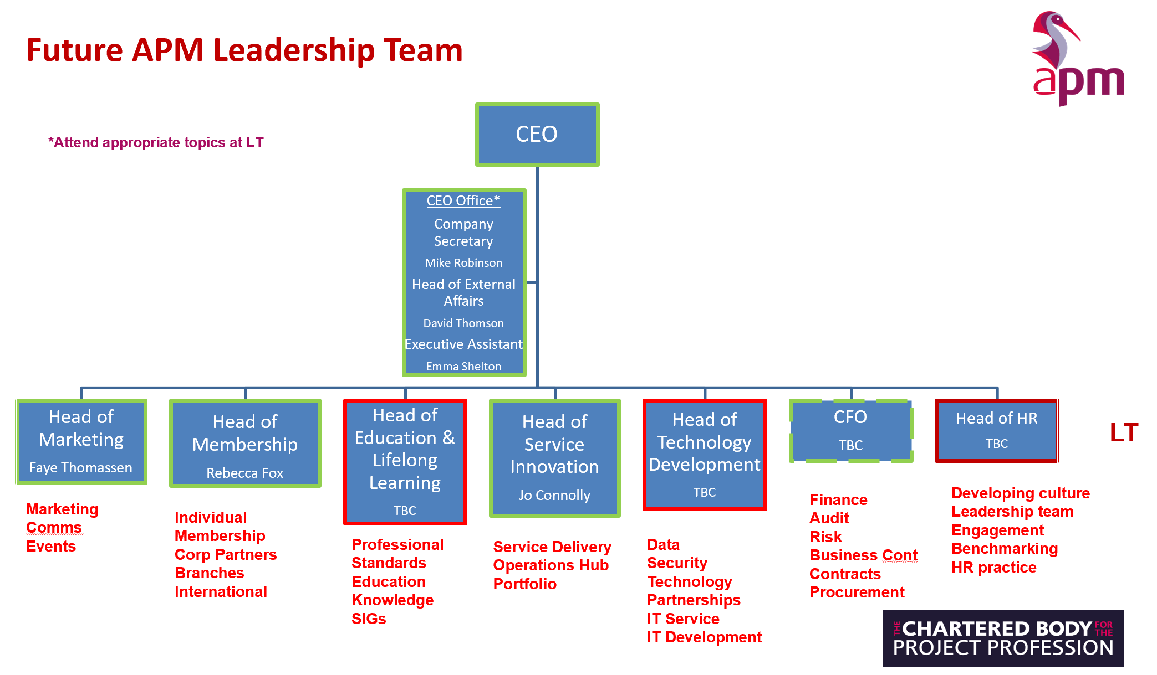
Leadership Org Chart

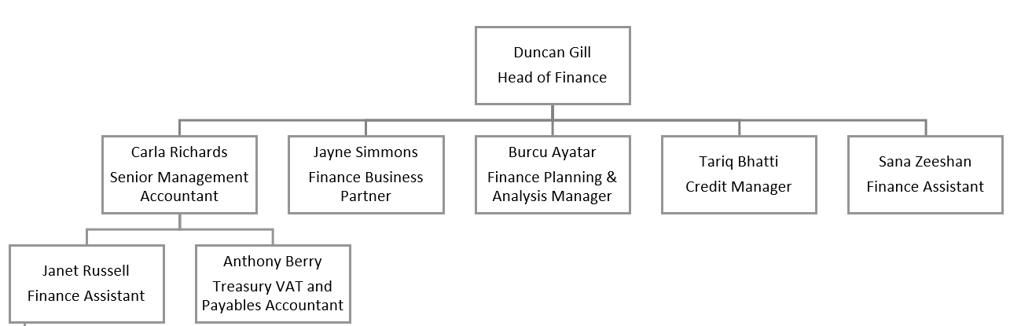
Finance Org Chart
Key Responsibilities

Job Purpose:

Role title | Chief Finance Officer |  |  | Department | Finance
Reports to (1) | Chief Executive |  |  | Reports | 9
Key relationships / interfaces (1) | Internal: | Chief Executive; Board; Company Secretary; Leadership Team and other headquarters staff; APM members and Audit & Assurance and Remuneration Committees
 | External: | Third-party suppliers and contractors; Banking services; Pension provider; Auditors; Revenue and Customs; Other regulatory bodies; Audit Bureau of Circulation (ABC)
Role purpose (2) | Responsible for leading the finance function within APM to ensure short and long term financial stability aligned to growth plans ensuring full compliance with statutory requirements.  Leading the annual cycle of business and financial planning monitoring performance through regular reporting of progress against agreed KPI’s  To be responsible for the effective management of the investment portfolio.
Breadth of responsibility (3) | This leadership role is responsible for all financial activity with the scope for making decisions within agreed authority and preparing proposals to the Board relating to APM’s financial strategy, also responsible for managing risk, business continuity and key contracts.
Dimensions and limits of authority (4) | Changes in strategy or delegations are approved by the Board and carried out in accordance with APM regulations.
Key responsibilities / accountabilities (5) |  |  | Key performance measures (6)
Key Responsibilities
- Be an effective and proactive member of the APM Leadership Team contributing to a high performing inclusive culture. |  |  | - Positive engagement with wider Leadership Team  - Clearly identified behaviours that achieve objectives  - Action taken on feedback from CE and peers
Support the CEO in developing APM in line with strategic and business plans, |  |  | - Provide clear reports on progress and issues  - Anticipate possible issues impacting on future plans suggesting possible solutions  - Plans and processes ensure no surprises to ensure confidence in financial and business delivery  - Drafting strategic KPIs for the organisation for approval by board
Manage APM’s current and future financial health, including income and expenditure and investment portfolio as well as long-term capital planning and funding. |  |  | - Wise and insightful financial decisions are made which maximise return for APM.  - Financial opportunities are identified and where appropriate presented to the Board for approval.  - All accounts, are prepared on time, and agreed by the Board.  - Lead and manage the creation of the agreed, annual APM Budget for revenue, capital and cash, together with the 3-year financial forecast.  - Effective management of the investment portfolio, cash flow, agreed budgets, revenue, capital.  - Lead and maintain effective strategic risk register
Manage the formulation and implementation of financial policy to meet corporate requirements. |  |  | - Policy meets and anticipates corporate requirements based on strategic and business plans  - Finance Department implements policy successfully.  - Managers across the organisation well informed and understand the policy implications
- Attend Leadership, Board, AGM and Committee meetings and contributing as appropriate. |  |  | - Regular attendee at Board meetings together with CE  - Positive contribution to all meetings with all necessary reports and financial information available as required for circulation prior to deadlines  - Expert opinion is presented on the financial health of the organisation.  - Role holder lead responsible for Audit and Assurance committee
- Responsible for ensuring proper business continuity and disaster recovery plans are in place. |  |  | - Plan is communicated and understood by key staff  - A regular review is undertaken to ensure plan is still current and relevant  - Regular review of plan undertaken in accordance with policy and by Audit Committee to ensure best practice is applied
- Ensure that appropriate internal financial systems and controls are in place within APM Headquarters and throughout its geographically dispersed network; to ensure that financial transactions and reporting comply with statutory requirements and financial best practice; and to optimise financial benefit to APM. |  |  | - Monthly reports are produced on time and to quality for use by stakeholders.  - Clear commentary is given on areas for improvement.  - Monitor and report actual progress against budget and forecast to ensure consistent achievement, including preparation of user-friendly monthly and quarterly management accounts and variance analyses.  - Liaise with the Portfolio team to ensure that the financial implications of the ongoing projects are properly reflected in the management accounts.  - Ensure that proper internal financial controls are in place and to devise and implement proper procedures and working practices to maintain those controls.  - Identify suitable planning data and statistics including externally-sourced comparative data.
- Lead the preparation of all statutory accounts and key financial statements. |  |  | - All financial systems and controls are in place and are consistent across the network.  - The financial requirements of each market within the remit are known.  - APM is compliant with all statutory requirements, is profitable and not in breach of any requirements and receives no financial penalties for non-compliance.  - Team has current knowledge of reporting requirements.  - Team produces accounts and statements accurately and on time.
- Lead all necessary audit work, including internal and external audit. |  |  | - APM is compliant and receives no penalties for non-compliance.  - Audits completed by the deadlines.  - Action plan developed, and progress tracked in response to audit results.  - Company procedures are appropriate to the production of the necessary information.
- Administer subsidiary / associated limited companies as requested. |  |  | - Companies are administered in a competent and efficient way.
- Advise and take responsibility for taxation issues. |  |  | - Up to date information is maintained about taxation and APM’s liability.  - Staff are trained as appropriate in how to manage the taxation elements of the accounts and audit them to ensure that the taxation is correctly calculated and paid.
- Manage contracts and procurement processes via the Contracts and Procurement Manager |  |  | - Tender strategy reviewed as appropriate and format amended accordingly.  - Tender process is proactively managed with supplier deals in place which benefit APM and which contain service level agreements against which the contract can be measured.  - Key contracts effectively managed  - Managers across APM supported to make effective contract and procurement decisions

- Champion the continuous identification of how value-for-money can be improved across all areas of APM operations. | - Feedback actively sought on how the process can be improved / performance of suppliers etc to identify areas for improvement through, for example, cost benefit analysis.  - Where appropriate, action is taken to ensure that APM has the best fit supplier.
- Line manage finance manager to ensure that their performance is managed in line with APM’s policies and procedures. | - Performance goals achieved.  - Appraisals completed on time and documented.  - Development plans in place and actively managed.  - Professional development actively supported

Person Specification – Chief Financial Officer
Attribute | Description | Essential / desirable
Qualifications (7) | - Educated to degree level  - Fully qualified accountant | - Essential  - Essential
Experience (8) | - Proven ability as a CFO preferably in a non-profit organisation.  - Demonstrable experience of working at senior level  - Experience of strategic planning  - Financial and business planning experience  - Team management experience  - IT development for financial management  - Audit work  - Demonstrable experience of change management  - Project management experience  - Commercial and business acumen | - Desirable  - Essential  - Essential  - Essential  - Essential  - Essential  - Essential  - Essential  - Essential  - Essential
Knowledge | - High level knowledge of accountancy techniques and principles  - Thorough knowledge of APM’s products  - Understanding of human resources issues  - Non-for-profit & private organisation environment  - Excellent knowledge of data analysis, risk management and forecasting methods | - Essential  - Essential  - Essential  - Essential
Skills | - Good PC skills including Word, Excel, PowerPoint  - Ability to use IT packages relevant to the role  - Excellent communication skills – written and verbal  - Ability to explain financial terms in simple language | - Essential  - Essential  - Essential
Behaviour / competency (9) | - Adaptability  - Analytical thinking  - Communication skills  - Decisiveness  - Developing and coaching others  - Initiative and proactivity  - Leadership  - Planning and organizing  - Resilience  - Results Orientation  - Technical and professional expertise | - Essential  - Essential  - Essential  - Essential  - Essential  - Essential  - Essential  - Essential  - Essential  - Essential  - Essential

Compensation: Guided – £90,000 to £95,000, bonus, 25 days holiday, 6% pension contribution, Individual Bupa and Dental, Death In Service, Laptop, Mobile Phone.

Location: Princes Risborough.

Travel: Occasional travel to London

Reporting to: Debbie Dore – Chief Executive

Team size: 9

Summary of some of the major attraction points:
- An outstanding CFO opportunity in a growing ‘award-winning’ membership association.
- A fantastic time to join and be a key Executive in the new Leadership team
- A broad CFO role that includes the delivery of the financial strategy, the opportunity to explain the financial trends, own the numbers, and provide financial guidance to all stakeholders.
- The opportunity to lead and develop an enthusiastic finance team through a period of growth.
- A Chartered Association that will continually strive to be ‘best in class’
- Modern office Headquarters in a semi-rural location, yet only 40 minutes from London Marylebone, and with easy access to the M40
- Operate within an open, fair, transparent, respectful, professional, ‘continuous improvement’ culture.

Tony Byrne  Managing Director  Phone Number : +44 7920151927  Email : tony.byrne@roberthalfes.co.uk | Birmingham  The Colmore Building 20 Colmore Queensway Birmingham B4 6AT
Jonathan Harvey  Senior Associate  Phone Number : +44 7789 271713  Email : Jonathan.Harvey@roberthalfes.co.uk  Sophie Pickering  Research Co-ordinator  Phone Number: 0117 993 5400  Email: sophie.pickering@roberthalf.net | London  10th Floor, The Shard  London Bridge Street  London SE1 9SG  London  10th Floor, The Shard  London Bridge Street  London SE1 9SG

