Our approach to developing a benefits management framework
By Neil White & Merv Wyeth
Introduction
The Benefits Management Framework workshop held at APM Portfolio Management SIG’s annual conference (May 2019), marked the latest in a series of Benefits and Value SIG knowledge sharing events. The workshop was designed to promote our approach to developing effective benefits management frameworks, whilst capturing the experience and collective wisdom of participants.
Our key ‘take-aways’ for attendees were:
- Benefits management frameworks enable consistent and effective benefits management across programmes, portfolios and entire organisations
- The development and introduction of a benefits management framework is greatly enhanced when considered and implemented through a change management lens
The four-stage approach
The main drivers for the four-stage approach was our mutual recognition of the need to respect the diverse nature of organisations and their people, coupled with their requirement and motivation, to learn from, and apply experience.
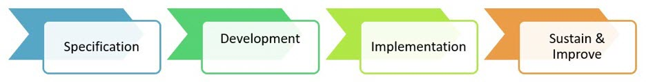
Diagram showing the four-stage approach to enable an effective benefits management framework
Establishing the need for a Framework
With this in mind, and our mastery of Mentimeter interactive presentation software, we first eased participants into the session with an icebreaker, followed by questions about their respective project-related roles and organisational focus, thus helping to understand ‘who’ was in the room.
Neil then set the scene by walking participants through the issues addressed, and key features of, a benefits management framework, followed by an important question ‘Does your organisation have a framework to manage benefits? Of the responses, 30% reported ‘Yes, but it isn’t really followed’ and 40% ‘No, benefits management is done by project and programme managers.’ This suggested (to us) that there was a fairly low level of maturity, and scope for improvement in the organisations represented by workshop participants.
After discussing the Organisational Change Impact Curve (which indicates that all organisations embarking on change initiatives will have to accommodate a degree of disruption), and its relevance to the topic area, Neil then identified 5 advantages to our staged approach (See below)
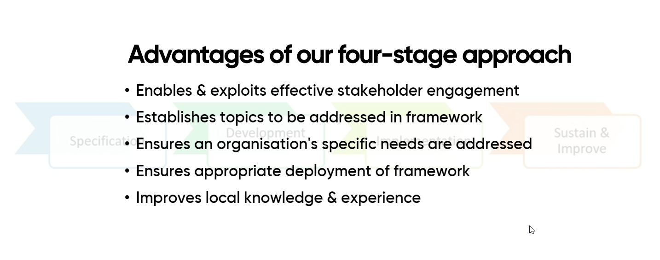
Workshop Exercise
Having established the purpose, and need for an effective benefits management framework, we moved on to an exercise, that reflected each of the proposed 4-stages; i.e. specification, development, implementation and sustain and improve.
For each stage, participants were invited to submit an individual response to a closed question framed in terms of ‘In my organisation…’ (time allowed 1 minute)
Then in pairs, or groups of 3, to have a conversation about how a benefits management framework might help to address known issues or drive improvement activity/increased maturity related to the respective stage. These suggestions were then submitted via Mentimeter. (time allowed 5 minutes)
In the results that follow below, individual responses from the participants are shown as bar charts, followed by a short commentary on selected responses received from the pairs/small groups. The full responses can be viewed here

#1 Specification
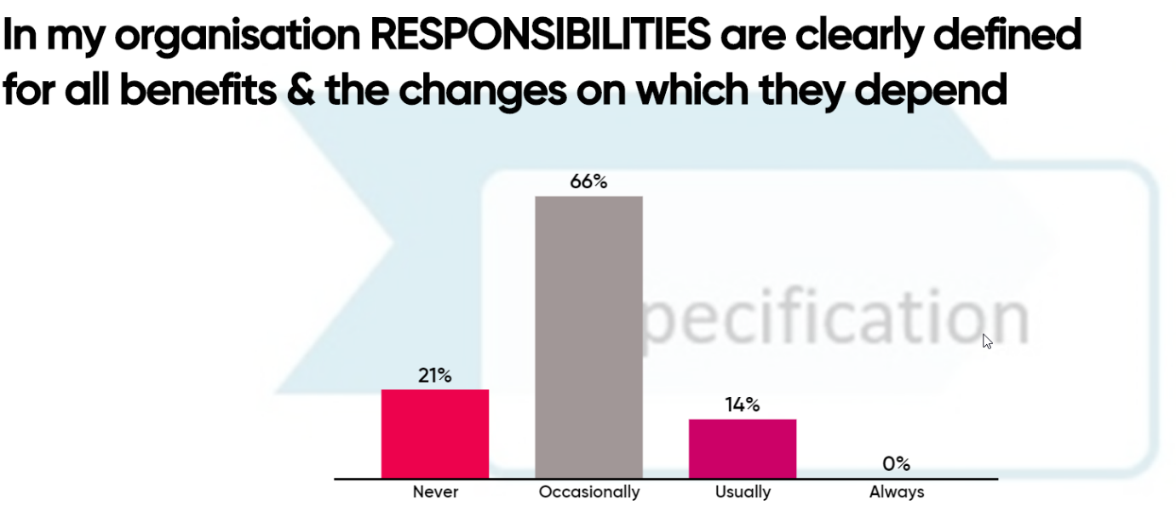
The results suggest that ownership and responsibility are a significant area for development as 87% of respondents answered ‘never’ or ‘occasionally.’
#1 How can a benefits framework help ensure that key responsibilities and ownership for benefits management are assigned and undertaken?
Respondents felt that a framework provides a vehicle for dialogue about value, in addition to guidance and rules; there needs to be a consequence for not following the framework. A framework provides a ‘point of reference and a Structured Toolkit.’
It defines the what, how and why of benefits management, tailored through tried and tested best practice feedback loops - not starting afresh every time! Benefits management should become the norm and a habit in organisational project management, and a framework helps to enable this.

#2 Development
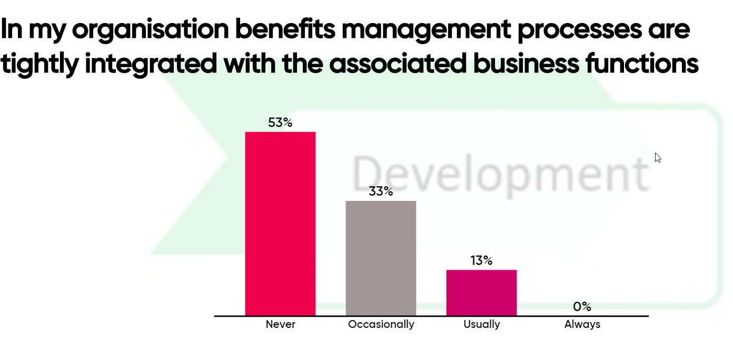

The results suggest that organisations do not tightly integrate benefits management processes with business functions, with 86% of respondents answering ‘never’ or occasionally.’
#2 How can an organisation ensure that its benefits framework is integrated effectively with other business functions?
Respondents felt that the framework should be co-designed by the business/operations and those responsible for project delivery and articulated in a ‘universal language’ tailored to the organisation.
Top down exemplar leadership, which includes ‘modelling the way’ (Kouzes and Posner, 1987) and board-level ownership are vital components of effective benefits management; and a structured approach to change and organisational culture. Project teams should include staff who are representative of the business areas affected by initiatives in the change portfolio.
Good management information is vital. Benefits metrics need to be tied to business performance and organisational objectives and contribute to the execution of corporate strategy. Further traction can be achieved by ‘Institutionalising the practice.’ e.g. making them part of JDs and PARs.

3 Implementation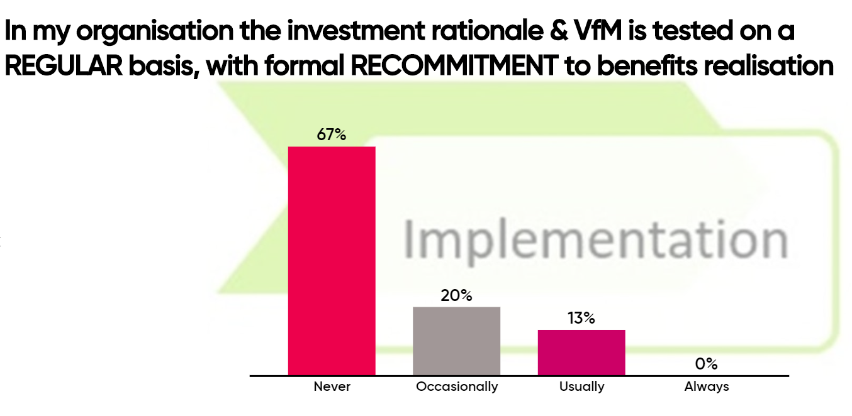
The results suggest that once projects and programmes are in flight, value for money testing and ongoing scrutiny of the benefits case (typically strategic and economic dimension) are rare with 87% of respondents’ answering ‘never’ or ‘occasionally.’
#3 How does a benefits framework ensure that maximum value is realised from its investment in change?
Respondents felt that that ways in which a framework helps to maximise ROI and NPV from its change portfolio include; enabling relevant and timely decision making (and interventions), stage-gates with clear assessment criteria and providing the opportunity for formalised periods assurance and verification.
Several felt that it was important to know when to stop projects e.g. applying the 80/20 rule to the creation and capture of value, in addition to linking benefits management to lifecycle management of products and services.

#4 Sustain and Improve
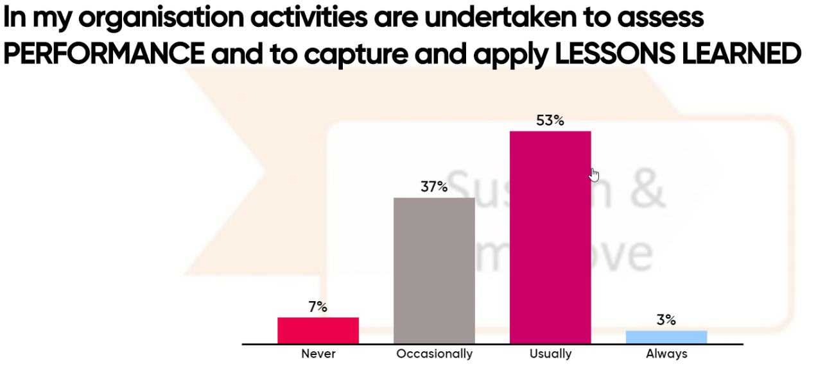
The results for this question are more positive, although they still suggest that there is room for improvement, with 56% of respondents indicating that performance is assessed, and lessons learned captured and applied ‘usually,’ and in one case ‘always.
#4 What steps can be taken by an organisation to ensure that its benefits framework remains fit for purpose?
Respondents felt that it was important to be open to challenge and not to be scared to change your approach if it is not working. Business champion owners can assist in conducting reviews and providing regular feedback.
Benefits management needs to be part of the culture and mindset of an organisation (the way we do things around here). P3M3 and CMMI (and the Praxis Framework) provide the tools and techniques to assess maturity capability. How are we doing now versus our baseline?
One respondent summed it up nicely ’The acid test - is it being used?’ linking back to the responses to the earlier question ‘Does your organisation have a framework for benefits management?’

Reflective Practice
At the end of the session respondents were asked to pause and reflect on what they had learned or would do differently as a result of their participation in the workshop. 32 pieces of feedback were received which suggested that every participant had got something out of the session. See screenshot below and note article Change behaviour if you want to create value from events #eventroi (Wyeth, 2015)
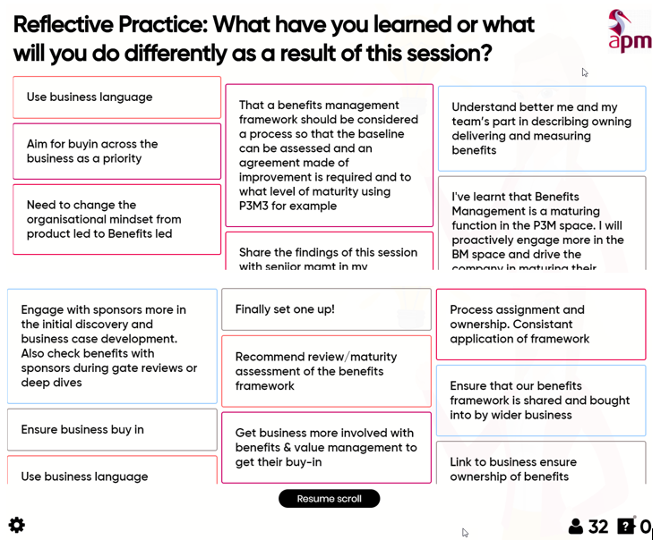

Facilitator Reflection
Although convinced of the merit of the four-stage approach to developing a Benefits Management Framework, this was the first time that we had ‘tested’ it in a workshop format. We need not have worried. The workshop proved to be popular with conference attendees, and from the outset participants were energised and engaged - even to the extent that, at times, we had to shout to make ourselves heard!
Reasons why we believe the workshop was so successful include:
- The clear and understandable logic behind the four-stage model that embeds intelligent change management thinking helping to mitigate problems and head off issues before they arise
- Having provided participants with a brief overview of the need, and context, for a benefits management framework, they were able to relate it to their own circumstances and experience
- The use of Mentimeter polling software enabled participants use their laptops and phones to share knowledge and experience
Profiles
Merv Wyeth https://www.apm.org.uk/profile/?id=253755
Neil White https://www.apm.org.uk/profile/?id=261137

