Dear Corporate representative,

On behalf of the APM Yorkshire and North Lincolnshire Branch (YNL), the Branch Corporate Advisory Group (BCAG) would like to extend a personal invitation for you to join us for a lunch and an afternoon of presentations and discussion on Friday 25th October 2019 between 12:00 and 4:30pm in the Wellmet Conference Centre, Cloth Hall Court, G04, Quebec Street, Leeds, LS1 2HA. This is a free event exclusively for APM corporate members and is aimed at experienced project and programme managers. It will provide excellent networking opportunities for attendees and the ability to meet with fellow professionals on a more informal basis and the opportunity to hear experienced quest speakers on areas of topical interest.

Guest speakers Hugo Minney and David Golding (APM Benefits and Value Specific Interest Group) will lead a session exploring ways to deliver effective benefits realisation management. Many organisations don’t review value as it is being created, which means projects can go badly off track, whilst continuing to drain disproportionately high levels of resources. Hugo and David will take delegates through the very latest thinking on using benefits management frameworks, based on the APM “Guide to using a benefits management framework” (published September 2019). This will be an interactive session involving both presentations and discussion points which will enable delegates to consider a range of issues including:

- The key components you need in any portfolio to realise benefits and create value
- How to align every project in your portfolio to your organisation’s strategic objectives, and make best use of scarce resources
- The difference between value creation and “nice to have”
- How to put a value on compliance and risk avoidance

A benefits management framework, if planned properly, can take a lot of the uncertainty out of successful project delivery. It can improve forecasts, clarify priorities, target investment, document and leverage dependencies and synergies, as well as realising strategic objectives.

A representative from the APM Business Team will also give a brief update on the areas of interest to corporate members, including Chartership.

Why not bring along a project management friend who is not a member of APM as your invited guest? If you are not able to attend yourself please would you pass this invitation to a colleague. If you have received this invitation and have an office in the region, please pass this on so that they are given the opportunity to attend.

A breakdown for the event is as follows:

Time | Event | Speaker
12:00-12:50 | Lunch & Networking, Merchant Hall, Ground Floor
12:50-13:00 | Welcome address, Cotton Room, First Floor | Andrew Fotherby, YNL branch
13:00-13:30 | Introduction to benefits and value | Hugo Minney, David Golding
13:30-14:10 | What is a benefits management framework | Hugo Minney
14:10-14:20 | APM Update | Austin Witney, APM Partner Development
14:20-14:40 | Refreshment break
14:40-15:05 | Discussion about existing benefits management frameworks and how (practically) to introduce one to an existing portfolio | Hugo Minney, David Golding
15:05-15:50 | Prioritising investment using the tools | Hugo Minney
15:50-16:00 | Input about potential topics for future corporate events | Hilary Pattison, YNL branch
16:00-16:30 | Closure with additional networking opportunities

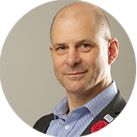
About Hugo Minney, ChPP, FAPM

Hugo has worked in project management in many different settings but has probably never once had the job title of ‘Project Manager.’ Hugo has worked across industries in Commerce, in Charity and NHS. Through all of this, Hugo has maintained a focus on value - the value that the user and the customer get, and why they would want to get (or buy) more.

Hugo has contributed to a number of publications in addition to the “Guide to using a benefits management framework”. These include “Social Return on Investment (SROI): A powerful tool for the realisation of benefits” and “Procuring for benefits and value” with the Contracts and Procurement SIG.

Hugo is a Chartered Project Professional and the Chair of the Benefits and Value Specific Interest Group (SIG), as well as on the committees of Enabling Change SIG and North East APM Branch. He’s a committee member of BSI (British Standards Institute) as subject matter expert for a forthcoming benefits management standard.

About David Golding, Bsc (Hons), Msc, FAPM

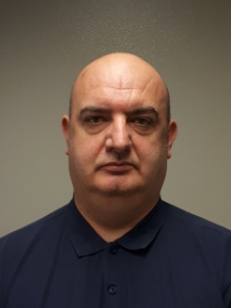
David has been involved in the construction industry for over 33 years, working across the public and private sector.

David's involvement with the APM has been principally focused on making Value Management a more recognised way to make projects and programmes generate better full life cycle benefits. David is a member of the Benefits and Value Specific Interest Group (SIG),

David has a BSc Hons degree in Project Management and a Msc in Strategic Project Management. Other personal development has been around Law and Contracts. David also became a Fellow of the APM at the start of 2019.

Spaces for this event are limited and offered on a first come first served basis so please email Catherine Bendell at catherine.bendell@apm.org.uk and Charlotte Bevan charlotte.bevan@apm.org.uk to reserve your place.

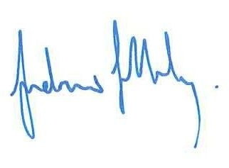

Andrew Fotherby, Hilary Pattison
Chair APM YNL branch Corporate Liaison YNL branch

