Minutes of the Annual General Meeting
of
Association for Project Management

Held on Monday 18th November 2019

at

Princes Gate Heritage Room,
30 Euston Square, London NW1 2FB
Commencing at 10.30 am

Association for Project Management
Ibis House
Regent Park, Summerleys Road
Princes Risborough
Buckinghamshire
HP27 9LE

Chairman of the meeting: Sue Kershaw, President of APM

Present: 25 full members were present, as detailed on the attendance list

In attendance: The Chairman of the Board, the Chief Executive, the Chief Financial Officer, the Company Secretary and others were in attendance.

Apologies: No apologies were received

Papers provided: Paper copies of the following were available for all attendees – Notice of the meeting, minutes of the previous AGM held on 19 November 2018, full annual report and accounts, the annual review summary, proposed amended Royal Charter and By-Laws (clean copy), commentary on the proposed changes to the Charter and By-Laws, Schedule of proposed changes to the Royal Charter and By-Laws, a tracked changes copy of the proposed amended Royal Charter and By-Laws and 8 questions received prior to the meeting with written answers.

Opening of the meeting
The President opened the meeting and welcomed those present.

1. The President’s address

The President addressed the meeting. She opened by commenting that it was a privilege to give the Presidential address to the Annual General Meeting (AGM) in such a successful year and an honour to do so at her first AGM as APM President. She acknowledged the contribution of David Waboso as previous President, not least in guiding APM to the receipt of the Royal Charter and through the launch of the chartered register and thanked him for his contribution. She stated that it had been inspiring, in her first duty as APM President, to speak to 6oo attendees at the Women in Project Management conference in September. She went on to pick out three stand-outs to illustrate the cut-through and momentum that APM is starting to make:

- The powerful evidence from the Golden Thread research of the size and impact of the profession;
- Progress on chartered, with nearly 900 ChPPs in the first year of operation and 1000 in sight soon; and
- Student membership growth, with numbers over 7,000.

She observed that these examples pointed towards the increased profile and status for the project profession.

The President went on to thank the Board members ending their service and welcome the new members to the Board. She also expressed thanks to all APM’s volunteers for their contribution to success. Finally, she thanked the Chief Executive and her team for the past year of success, recognising the momentum made in the past year and the great platform created for 2020.

2. Minutes of the Annual General Meeting of the company held on 19th November 2018

The minutes of the previous Annual General meeting were approved and signed by the Chairman of this meeting.

3. Receipt of the annual accounts of the company Association for Project Management for the year ended 31st March 2019, the report of the trustees and the auditors’ report

The President invited the Chairman of the Board and the Chief Executive to present to the meeting on the strategy, the achievements of the year, annual report and accounts for 2018/19, and forward plans.

The Chair of the Board opened the presentation. He referenced APMs current strategy and high-level objectives previously set by the Board which are helping drive APMs continued growth. He also referred to four new initiatives which have commenced in 2019 as follows:

- Support and mentoring for Small to Medium sized Enterprises (SMEs) – the launching of a pilot programme for SMEs to assess their adoption of good practice in all aspects of Project Delivery and provide a route map for improvement;
- Giving back through training and support for charities – investing in free support and training for charities to improve project outcomes;
- Making better use of project data – this is at an early stage to support the profession initially through research and chairing a pan-sector working group; and
- The APM brand review – the current brand was initiated in 2005 and was updated to reflect Chartered status in 2017; APM has commissioned a brand consultancy to undertake research and it is expected that the Board will have a recommendation to consider in March 2020.

He then moved on to how APM is addressing the climate emergency explaining that APM recognises that project managers have a role to play in this and is developing APM’s commitment to doing so and providing a pledge that project managers can sign up to, developing APM’s own green credentials and highlighting innovation and best practice.

Finally, he summarised what APM stands for:

- Setting the standards for the profession – creating and upholding standards for the profession;
- For everyone – representative of the whole profession;
- The leading source of knowledge and insights – for the profession;
- Listens – adapts, acts and advocates for the profession, and
- Promotes the power of the profession for good.

The Chief Executive then presented on achievements during the past year, which included:

October 2018 Launched online application for Chartered Register
November 2018 Launch of new IPMA qualifications & APM qualifications decoupled from IPMA
November 2018 Career path tool
November 2018 Commenced roll out of digital badges (43,000 downloads)
March 2019 Revised MAPM standard and joining process
March 2019 APM Learning – an online learning platform free to all members, which will grow
March 2019 Ibis House consolidation and extension project
March 2019 APM Body of Knowledge 7th Edition]
March 2019 Online PMQ pilot started

- Chartered standard – Register launched October 2018, expect to have 1,000 Chartered Project Professionals on Register in December 2019;
- Further key activities including – diversifying into new sectors, continuing to invest internationally, an advertising campaign that reached 3.2 million people and a new advertising campaign scheduled for January 2020, the schools engagement campaign which reached over 75,000 students in its first year with 450 schools downloading packs and a series of University visits and continuing progressive engagement with other bodies;
- Knowledge and research – over 2% of revenues have been invested in innovative research, including the Golden Thread research in collaboration with PwC and the establishment of the Projecting the Future Group with over 50 pieces of thought leadership published over the year;
- Volunteering remains the core of APM with over 600 volunteers not in SIGs or Branches with a more diverse range of volunteering activities for a more diverse range of people;
- The Membership survey, with 2789 responses, provided a positive score of 29; and
- APM was the 2019 winner of Overall Best Association over 1000 Members and was awarded a Bronze for the Best Association Awards Event.

The Chief Financial Officer then presented the 2018/19 Financial Report as follows.
Income was up on the previous year by 17% delivering a net surplus of £567,000 compared to a £129,000 deficit in 2017/18. There was a 25% growth in qualifications income and attendance at events was higher than ever. The number of people taking the PMQ exceeded 10,000, up 7%. The membership is now 30,000, up by 16%, with a 12% increase in Associates and a 79% increase in student membership. There are 17% more international members. There are 500 organisations who have joined APM’s corporate partner programme. Expenditure has increased by 11%, with investment in qualifications and offices. The balance sheet remains strong with £6.6 million net assets. The finances remain strong and will support future plans. The Audit and Assurance Committee have considered the question of auditors and whether Kingston Smith should continue as auditors. Considering that there is a new audit partner in place and that APM has a new CFO, it was agreed that it would be beneficial for Kingston Smith to remain as auditors of APM.

4. Special Business

The Company Secretary introduced the proposed Special Resolution. He explained the role of the Charter. He confirmed that the charitable objects and powers of APM would remain unchanged but that after a review by the Board the intention was to tidy up and clarify wording and follow best practice. He explained that if the changes are approved by special resolution of the meeting, the proposed changes would then be submitted to the Privy Council for approval. The Company Secretary referred the meeting to the summary of changes that had been provided and invited questions.

A question was raised from the floor asking the number of members that would be required in order to requisition a general meeting under the proposed new provision. The Company Secretary explained the thinking behind the proposed change and confirmed that with current membership numbers of those entitled to vote, 143 members would be required to requisition a general meeting; this would vary depending on the number of voting members. He suggested that this was not an unduly high number and that raising the required number from 25 would prevent the possibility of frivolous requisitions, which might cause APM undue and unnecessary expense.

The following resolution was passed unanimously by the meeting as a SPECIAL RESOLUTION:
THAT the Charter and By-Laws [as can be viewed online at www.apm.org.uk/AGM2019] and for the purposes of identification marked ‘A’ are approved and adopted as the Charter and By-Laws of the Association in substitution for and to the exclusion of the existing Charter and By-Laws of the Association, subject to formal approval of the Privy Council and subject to any minor amendments that the Privy Council may require.

5. The APM Board election

The Company Secretary reported the results of the 2019 Board election as follows:

- APM has continued its upper quartile performance in terms of turnout - 19.9% achieved this year, which was a record turnout
- Under the Charter and Regulations, the election was undertaken as a poll vote with the ballot delivering proxies to the AGM
- The three candidates receiving the highest votes are elected for three-year terms and the fourth placed is elected for a two-year term.

The Company Secretary congratulated all those who participated and voted for a good election process.
The result of the election was as follows:

Candidate Votes
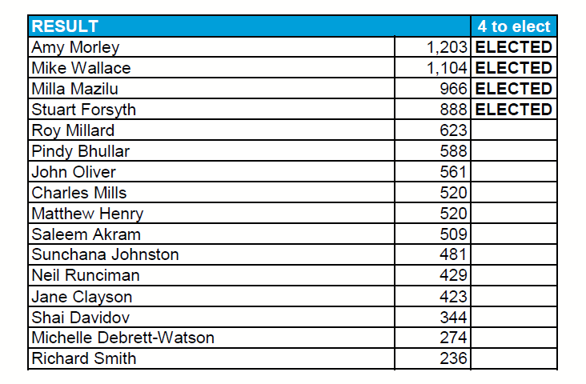
So, Amy Morley, Mike Wallace and Milla Mazilu were elected to the Board for a period of three years and Stuart Forsyth was elected to the Board for a period of two years.

6. Members’ questions

The President then turned to the members’ written questions submitted in advance of the meeting. 8 questions had been submitted and copies of the questions and written answers had been made available to all those attending the meeting.

The President then asked if anyone wanted to comment.

David Coombes (DC) followed up on his questions about the Registered Project Professional (RPP) standard and register as follows - The written answer had confirmed that it was intended to close entry to RPP from December 2020 but to maintain the register. DC asked whether those on the RPP register would still have to pay a fee? The Chief Executive confirmed that APM will maintain the register after December 2020 and is considering whether it should retain the requirement for payment of a fee for remaining on the register. The Chair of the Board confirmed that the question of whether the RPP fee should be retained was something that could be considered.

Tom Taylor (TT) suggested that APM should say more to the membership about what they could and should be doing about sustainability and that APM should provide some leadership in this area. The actions already being taken by APM were set out in the written reply to TT’s written questions and his further comment was duly noted.

The President then made closing remarks.

The Chairman of the Board thanked everyone for attending, expressed thanks to the Board and the Executive for their work over the last 12 months, expressed thanks to Susie Boyce and Nick Smallwood (the trustees leaving the Board) for their service to the Board and welcomed the new trustees joining. He also expressed thanks to Sue Kershaw for agreeing to become the first female President of APM

The meeting closed at 11.20am.

Chairman______________________________

