**APM Festival of Education & Research Judge Application 2020**

|  |  |  |  |
| --- | --- | --- | --- |
| **First name:** |  | **Last name:** |  |
| **Contact telephone:** |  | **Email address:** |  |
| **Home address:** |  | | |

|  |
| --- |
| **How did you hear about the role?** |
|  |

|  |
| --- |
| **Why would you like to be considered for the role?** |
|  |

|  |  |  |  |
| --- | --- | --- | --- |
| **Employment history:** | | | |
| *Dates* | *Role* | *Company* | *Key projects and achievements* |
|  |  |  |  |
|  |  |  |  |
|  |  |  |  |

|  |
| --- |
| **Is there a category that you would prefer to judge? If so, please state why you would be suited to this category.** |
|  |

|  |  |  |
| --- | --- | --- |
| **Previous awards judging history:** | | |
| *Year* | *Awards* | *Category (for APM awards only)* |
|  |  |  |
|  |  |  |
|  |  |  |
|  |  |  |

Please send a copy of your CV and a signed copy of the Code of Conduct form to [festival@apm.org.uk](mailto:festival@apm.org.uk)

**APM Code of Conduct**

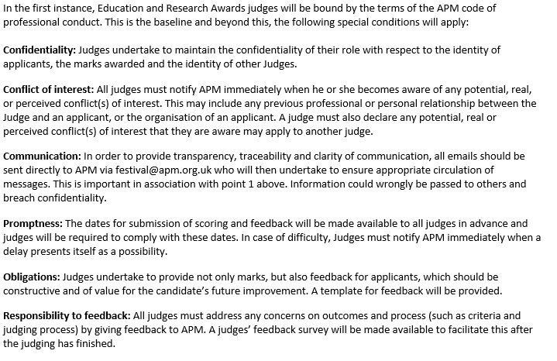

**Signature:**

**Full name:**

**Date:**