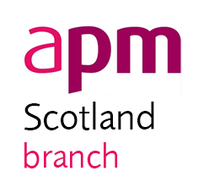

Project Challenge 2020/21
  - Guidance Document

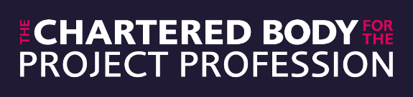

Executive Summary
The APM Scotland Project Challenge is an annual competition for developing project management professionals. Teams from organisations and universities deliver a project to the benefit of their chosen charity.
The aim of the challenge is to improve the competitors’ project management skills in a real-life environment with the support of a professional mentor, while at the same time helping local charities and raising the profile of the project management profession. The challenge is run over a number of months and culminates in a prestigious finals night.

Contents
Executive Summary 2
Contents 3
About APM 4
APM Strategy 4
Five Dimensions of Professionalism 6
Body of Knowledge 7
APM Competency Framework 7
About APM Scotland Branch 7
Project Challenge Objectives and Benefits 8
Previous Winners of the APM Scotland Project Challenge 2018/19 9
Project Theme 11
Milestones, Timeline and Instructions 12
Competition Rules 16
Assessment Criteria & Weighting 17
Roles and Responsibilities 18
Mentors 18
APM Scotland Branch Competitions Committee 18
Project Teams 19

About APM
The Association for Project Management (APM), the chartered body for the project profession, is committed to developing and promoting project and programme management through its FIVE Dimensions of Professionalism. In 2017, APM was awarded a Royal Charter as part of its strategy to raise awareness and standards in the profession. The receipt of a Royal Charter marks a significant achievement in the evolution of project management. There are a number of ways in which you can benefit from what we do, including:
- membership
- qualifications
- publications
- events
The APM has over 30,000 individual members and 500 organisations participating in the Corporate Partnership Programme making it the largest professional body of its kind in Europe.

APM Strategy
The APM strategy reflects the recent transition to the chartered body for the project profession. Awarded to APM in April 2017, the Royal Charter provides the profession with a platform to raise awareness of our skills, improve standards and develop our practice for the benefit of all.
The APM continues to change in order to meet the challenges of a complex and dynamic world. APM believes this rapidly changing environment calls for a more adaptive project management approach, which is more inclusive and responsive to the needs of society. One which builds a community of credible, capable and trusted professionals delivering positive, effective change across all sectors and to all stakeholders.
A world in which all projects succeed with project management as a life skill for all.

Our vision for the profession is ambitious, challenging and radical. Above all, it reflects what society expects: A world in which all projects succeed.
We cannot deliver this vision alone.
Inspiring communities to deliver meaningful change for societal benefit by advancing the art, science, theory and practice of project management
The APM mission, our purpose, is to inspire communities who are engaged in delivering meaningful change to apply the art, science, theory and practice of project management. Equally, APM is committed to advancing our collective knowledge and, in doing so, contribute directly to achieving our vision.
Our mission is underpinned by five key objectives, which set out a clear direction of travel for APM.
Successfully position, develop and launch the chartered standard to become the accepted benchmark standard for project professionals. | Accelerate the growth, diversity and global reach of APM’s membership by engaging with new sectors and communities. | Advance the art, science, theory and practice of project management with an innovative knowledge and research programme.
Define and build APM as the model of a sustainable professional body for the 21st century. | Accelerate the universal adoption of project management by people delivering change through collaboration and partnerships.

Five Dimensions of Professionalism
The APM, the chartered body for the project profession, supports professional values. The APM FIVE Dimensions of Professionalism provide a framework that helps you develop your career.

Breadth
The APM Body of Knowledge defines the knowledge needed to manage any kind of project. It underpins many project management standards and methods including the National Occupational Standards in Project Management.

Depth
The APM Competence Framework provides a guide to project management competences. It is part of your professional toolkit; mapping levels of knowledge and experience to help you progress your skills and abilities.

Achievement
APM qualifications take your career in new and exciting directions. They are recognised across the profession and aligned with IPMA’s 4 level Certification Program.

Commitment
Continuing Professional Development helps develop your project management practice. A targeted development plan will enhance your project management career.

Accountability
The APM Code of Professional Conduct outlines the ethical practice expected of a professional. Becoming an APM member shows your commitment to the Code and sets you apart from others.

Body of Knowledge
The APM Body of Knowledge 7th Edition (https://www.apm.org.uk/body-of-knowledge/) defines the breadth of the project, programme and portfolio management profession. It makes up one of the FIVE Dimensions of Professionalism.
The APM Body of Knowledge definitions can be found on the APM Knowledge site (knowledge.apm.org.uk) broken down into the 80 topic areas which are contained in the full text. Topics are divided over four sections; context, people, delivery, and interfaces.

APM Competency Framework
The APM Competence Framework (https://www.apm.org.uk/resources/find-a-resource/competence-framework/) sets out the competences required for effective project, programme, portfolio management and project management office (PMO). The framework consists of 27 competences based around outcomes that project professionals need to achieve. Each competence includes a series of criteria covering knowledge and the application. It also includes a Ratings Scale, a simple 5-point scoring system for assessing performance against the application and knowledge criteria (aware, practiced, competent, proficient and expert).
The marking schedule for this year’s Project Challenge will have alignment with the competency framework at its heart and this should be used as a core reference for teams undertaking it.

About APM Scotland Branch
Scotland Branch deliver a programme of activities aligned to the APM 2020 Strategy. Using the 27 competencies from the APM Competence Framework as a guide our programme aims to be diverse, inclusive and of interest to the full spectrum of our membership from Student/Entry-level through practitioner and up to Director/CxO level.
Where we can we focus our events on experience and lessons from key projects of Scottish interest and we work closely with Scottish Government, our Corporate Partners, Members, Affiliates and Higher Education Institutions to ensure we understand their needs and how we can work together for the benefit of all of our members and the wider project profession within Scotland.
Our prestigious annual Project Challenge Competition provides development opportunities for newcomers to the profession whether from corporate companies or HEIs, and we are actively looking at opportunities to further develop and enhance our activities in this area.
Our membership is widely dispersed, stretching from Dumfries and Galashiels in the south, to Wick in the north, any beyond when you factor in our members in the Hebrides, Orkney and Shetland Islands. Our principal concentration of members is focused on the principal cities of Edinburgh, Glasgow & Aberdeen and are drawn from a diverse background, including the Public & 3rd Sectors, Digital & ICT, Defence, Civil & Construction, Transportation & Aerospace, Energy & Utilities, Financial Services, Manufacturing and Retail.
Our challenge is to meet the professional project, programme & portfolio management needs of this diverse and geographically distributed population. We have been growing and now have over 2000 individual members across the membership grades. We also have over 50 Corporates with head offices in Scotland, and some 360 plus based outside Scotland with one or more offices in Scotland.

Project Challenge Objectives and Benefits
The prime objectives of the APM Scotland Project Challenge are to deliver a range of professional learning benefits to individual team members as well as corporate participants. The challenge is open to new entrants to the project management profession and students of project management and the key objectives of the competition are:
- Individual – Improve project management skills and experience within the competing teams;
- APM – Assist early career project management practitioners in gaining the skills, experience and networks in support of the wider APM Mission;
- Charities – The charities supported by the teams benefit from increased profile and fundraising.
Additional benefits include:
- An excellent opportunity to develop and practice professional competences associated with project management in a realistic environment from concept to completion;
- An opportunity to be mentored and work alongside experienced project professionals;
- Gain real-life project experience and practice a wide range of competences and skills to deliver a solution;
- Develop knowledge of the success criteria and qualities required to deliver a successful project;
- Develop a better understanding of the personal qualities required to become an effective project manager and leader;
- An opportunity to compete and gauge your performance against other aspiring project professionals in the Scotland region;
- An opportunity to enhance the project management learning experience within the corporate and further education environments (Continual Professional Development);
- A high-visibility example of successful project management delivery and implementation which should provide beneficial publicity for the corporate team sponsors.
This is also an excellent way to develop and practice your project management skills in a real project environment. It is also a unique addition to your CV.

Previous Winners of the APM Scotland Project Challenge 2018/19
The winners of the 9th APM Scotland Project Challenge 2018/2019 were Team Ripple from Scottish Water. Ripples project was to restore a disused area of land, owned by their chosen charity – the RSPB, into an educational sensory garden which informs visitors of the water cycle.
They defined their project scope as:

“To construct a sensory garden which delivers an educational benefit that is in line with the project’s objectives. The sensory garden must utilise as many recyclable materials as possible and look for innovative methods to deliver the projects objectives”.
The team members included
- Chris Arnold - Project Manager,
- Katiera Donnelly - Design Manager,
- Kenneth Brydon - Risk Manager
- Helen Wall - Finance Manager
- Darrell Muldoon - Customer Manager
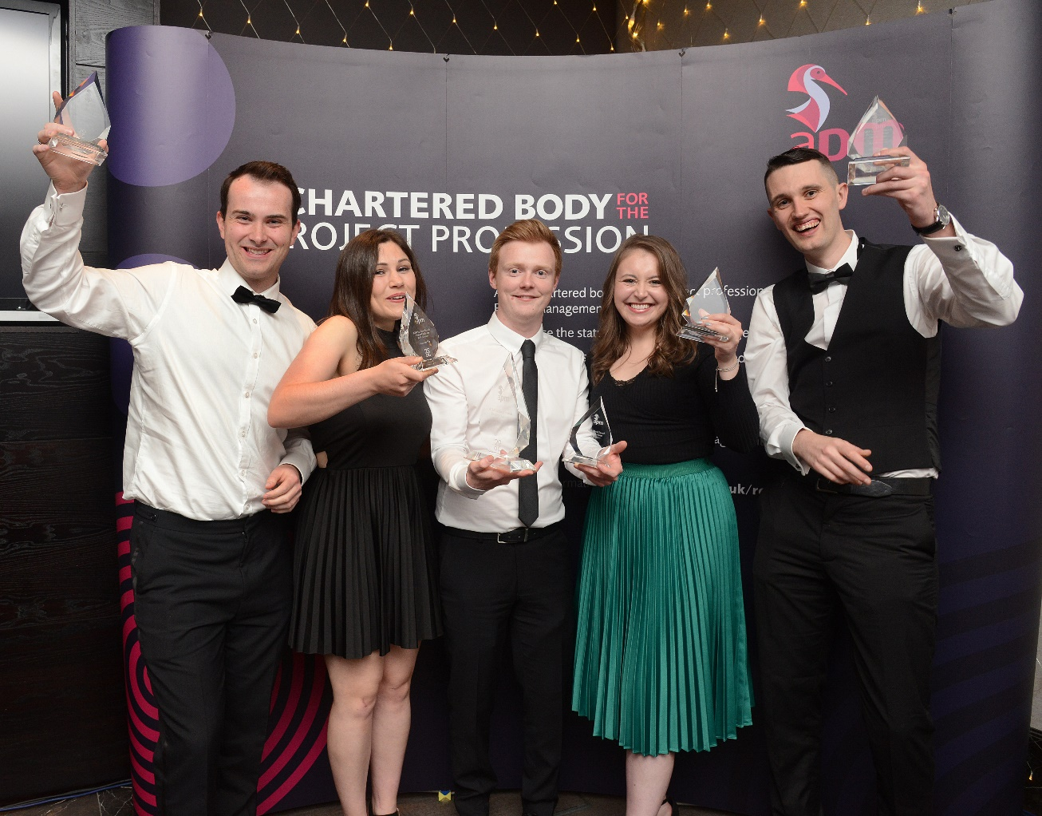

Team Ripple chose the RSPB as their charity partnership. The benefits of the project charity were identified as the nature reserve is a popular destination for Motherwell locals and boasts an active volunteering base. The team identified that there was the potential for high usage of the garden after completion and were able to utilise RSPB volunteers to help with construction.
The benefits of the project were set out as follows:
- The garden offers a relaxing, educational and socially inclusive area for members of the community to enjoy;
- Improves the local ecology of the land and provides a habitat for a range of wildlife;
- Construction contributes to increase social and natural capital in the community.

Previous Winners of the APM Scotland Project Challenge 2019/20
Team Purple change from Leidos were the winners of Project Challenge in 2019/20. It was a challenging competition due to the global pandemic which impacted many of the teams projects. The finals event was hosted online where each of the final teams presented their final project to the judges.
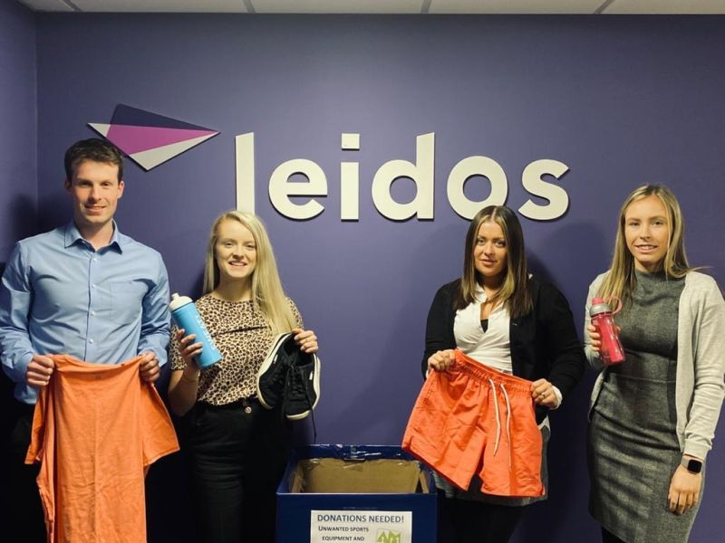
The team members were:
Catherine Fevre, Jennifer Clelland, Callum Harley, Vickie McArthur and Euan Brady.
The project aim was to provide Achieve More Scotland with a sustainable solution to providing their young people with the appropriate sports clothing and equipment to take part in physical activity – ultimately reducing the carbon footprint and costs involved in purchasing brand new sports equipment. The project objectives were to deploy 5 collection bins and collect 50kg worth of kit and equipment across Glasgow and to raise £700 to cover project costs and provide a donation of £500 to the charity. The team also wanted to raise the social profile of the charity and to improve their own project management skills throughout the experience. The project was a resounding success. The team collected 81.57kg of equipment and were able to raise £727 in donations. They were also able to facilitate a relationship to potentially form a partnership between the Glasgow Warriors Rugby Team and Achieve More Scotland.
Catherine Fevre, Project Manager, said ‘I am proud of what the team and I have been able to achieve over the last 10 months, despite COVID-19 and the impact this has had. As an individual, I believe I have developed my project management skills and grown confidence in my ability to lead during uncertain times.’

Project Theme
Following recent events that have impacted all of our projects in ways we could not have predicted - the project challenge theme this year is adaptability & agility. This should be considered when carrying out your project with a core aim being to demonstrate innovation while benefiting a charitable organisation.
Participating teams are expected to define, plan and deliver a project that demonstrates the theme while also benefiting their selected charity or community based project. The benefit is usually in the form of fundraising, but can take other forms which the team may reflect in their progress updates. The project must show adherence to project management best practices in line with APM project management principles.
The teams that make it to the final will be invited to share their experiences with fellow professionals from across the profession culminating with the announcement of the winning team at our annual awards dinner in June 2021. This plan will be kept under review and any event will be planned in line with any government restrictions relating to COVID-19.
The judges will be looking for evidence of reference to the project theme throughout the deliverables provided over the life of the competition.
Teams who do not progress to the final stages of the competition detailed below will be invited to complete in a secondary poster competition details of which will be released after the first stage of the competition.

Milestones, Timeline and Instructions
Date | Milestone | Instructions
Week Commencing 2nd November 2020 | Competition Launch | Read Project Challenge documentation, identify and build a team.
8th January 2021 | Team Entry Deadline | Complete and submit the Team Entry Form. The teams of 3-5 members can represent universities, colleges, corporations or a collaboration of the three. Independent teams are also welcome. Once you have submitted your entry by email to SPMC@apm-scotland.org.uk you will receive an invite to join the online competition collaboration portal – MS Teams. Once this access is provided all dialogue and submissions should take place via Teams.
29th January 2021 | Proposals Submission Deadline | Complete and submit your Proposal submissions via the online portal site.  Your proposal should comprise of two key deliverables:  - A Project proposal document using the template provided. The project proposal should benefit a charity or community project of their choice.  Project Proposals must contain no more than 3,000 words including appendices. Failure to adhere to this word limit may result in the proposal not being fully marked. The judges will be looking for quality, not quantity.  - A Project Presentation video recording (.MP4 format). The presentation should last no longer than 15 minutes. Teams are encouraged to be creative in the way they present their proposal and may use any other supporting material they feel is appropriate during the presentation. All team members should feature in the presentation.
Week commencing  15th February 2021 | Project Clarifications | Following review of proposal submissions teams may be contacted by telephone or conference call to answer any clarifications that the judging panel may have.
26th February 2021 | 1st Interim/ Progress Report | All teams will then be asked to create an Interim/Progress Report in the form of a single sided poster (Max size A0). The poster should introduce their project, team and charity and give an overview of the progress made to date in anticipation of being down-selected.  Initially poster designs should be submitted electronically via Microsoft Teams as either as a document (.PDF, .DOCX, .PPTX or .VSDX) or as an image file (.PNG or .JPG).  The highest scoring team(s) from proposal submissions & 1st interim reports will then be down selected, assigned an APM mentor, receive their seed funding of £100 and go on to execute their project and compete in the finals.  *Down selected teams may be asked to print their poster for display at APM events.
12th March 2021 | Finalists announced and Mentors Assigned | An experienced project management professional will be assigned to each team to act as a mentor throughout the project. Only one mentor will be assigned by APM; however you are free to get mentoring & coaching support from additional sources, such as your University or Organisation, but this must be arranged by the team.
12th March 2021 | Poster Competition | Details of the poster competition for runner up teams released.
12th March 2021 | Funds Issued | Seed funds will be released by way of application to the teams. The maximum funds per team is £100; however additional benefits in kind are allowable from external parties provided they are appropriately recorded in your project accounts – for example discounts on materials, volunteers’ time, or free loan of equipment.  Any unused funds at the end of the project should be added to the total donated to the chosen charity.
31st March 2021 | 2nd Interim Report Deadline | Complete and submit a more formal 2nd Interim/Progress Report using the template headings provided and upload via Teams.  It is strongly recommended by the Competitions Committee that the team arrange to discuss the interim report with their mentor to obtain their feedback.
14th May 2021 | Final Report Deadline | Complete and submit your Final Report electronically as a document upload via Microsoft Teams (either .PDF or .DOCX format).  Final Reports must contain no more than 5,000 words, including words to describe any graphics and should be no more than 25 A4 pages, single sided. Anything over this limit will not be marked by judging panel.  All teams will be expected to progress their projects to a significant completion milestone corresponding with this Final Report Deadline. Due to the relatively short timeframe from Proposals submission through to Finals Night this milestones does not necessarily have to be the final project delivery milestones; however consideration should be given to how the team can demonstrate achievement of the project objectives.
14th May 2021 | Project Summary | A project over view page that summarises the team and the project. This should be A4 landscape in format which will be printed as 2 x A5 portrait pages which is submitted as a .pdf file. This will be used at the finals event night to showcase the projects to the audience and will be printed in a booklet which will be on tables.
14th May 2021 | Presentation Submission | Submit your presentation files in preparation for progress update presentations via project place:  - The final slide deck for your presentation  - A 150 second video of the project and team  The presentation should be no longer than 15 minutes and should look to provide an overview of the project including its current status, how the benefits of the project will be realised and should include what lessons the team has learned from participating in project challenge.  The final presentation should encompass the full breath of the project and the judges will be paying particular attention to the impact and effectiveness of activities not just adherence to project management process.  The video should be an overview of the project, who you are as a team and look to focus in on both the impact you as a team have had and how you have applied benefits management within the project.
End May / Early June 2021 | Final Presentations | Present your project overview and post project learning to a panel of judges and a live audience. The team should prepare for any questions that the judging panel or audience wish to ask.  The presentations will take into account any COVID-19 restrictions and relevant government guidelines.
Late June 2021 | Winner Presentation | Winners will be announced at the APM Awards evening alongside a number of other individual award categories. Ticket availability and booking details will be announced when the date for the presentation has been confirmed.  The event will take into account any COVID-19 restrictions and relevant government guidelines.

Competition Rules
- Each team must consist of a minimum of 3 and a maximum of 5 members;
- All official entry forms should be sent to SPMC@apm-scotland.org.uk;
- All other submissions should be made through the collaboration portal on the online portal provided by the APM;
  - Formal Reports should be submitted in either .PDF or .DOCX file types
  - Posters should be submitted as any of the following formats .PDF, .DOCX, .PPTX, .VSDX, .PNG or .JPG
  - Video files as .MP4 format
- Each team is to prepare and execute a project of their choice to benefit a charity or community project of their choice;
- Participating members should have a maximum of 3 years of project management/project controls working experience. It is the responsibility of the lead member of each entry team to ensure this is adhered to;
- The budget must be fully accounted for and receipted back to APM;
- There is no limit to external funding that can be sourced by each Project Team;
- Since APM is a charity it cannot donate money to another charity. Each team will donate the money they raise directly to their chosen charity;
- APM Scotland reserve the right to adjust one or more of the competition constraints / deadlines / rules in order to simulate a ‘black swan’ event;
- The judges’ decision is final. No correspondence concerning their decision will be entered into. Entries submitted after the deadline will be rejected;
- Entries will only be accepted when submitted in the English language;
- The content of all submissions remains, at all times, the copyright of the advocate or candidate as appropriate, but APM Scotland Branch may wish to reproduce some content for the purpose of promotional materials such as: winner case-study, PR or other. If an advocate or candidate does not give automatic permission for material to be reproduced without prior discussion, this must be noted on the entry submission;
- APM Scotland Branch reserves the right to accept or reject entries, and/or not make an award, as circumstances dictate;
- The judging panel will consist of individuals who are experienced APM Full Members, Fellows or ChPPs;
- All entries are made at the expense of the candidate and/or their employing organisation;
- No submission will be returned once the judging process is complete;
- APM board members, committee members, members of other APM groups, staff and judges are subject to the association’s conflict of interest policy, Board member Code of Conduct and/or the APM Code of Professional Conduct. Any breaches will be addressed through the existing mechanisms, including the APM Professional Conduct procedural rules.

Assessment Criteria & Weighting
The SPMC teams will be marked across the six deliverable elements which will be weighted as follows:
- Project Proposal– 20%
- Interim Report 1 – 15%
- Interim Report 2 – 15%
- Final Report – 25%
- Final Presentation – 25%
Please note the assessment criteria will focus on the following topics:
- Compliance to the rules and submission deadlines outlined in this document
- The adherence to the theme and its overall execution
- Evidence of application and alignment with the APM Competency Framework
All phases of the competition will be judged by a selected panels of established project professionals appointed by the APM Scotland competitions committee. Please note that all judging decisions are final.

Roles and Responsibilities

Mentors
The role of the mentor is to provide both a source of information/knowledge and a sounding board. The mentor’s role is one of facilitation. Project teams are not obliged to accept the advice provided. The mentor should also strategically assess and monitor progress and give advice for effectiveness and efficiency. Mentors should not provide solutions, but ask questions to stimulate the project team’s own thinking and development of their own solutions. Mentors are responsible for ensuring that each team runs a unique style of project.
The project team should choose the interface with the mentor; how often to meet, format of meeting and communications and focus. The mentor should agree this interface programme with the team as soon as possible.
As a guide the following would be a suggested minimum interface programme:
- Initial meeting
- 2nd interim report review
- Final project report review
Mentors should be the single point of contact between the project team and APM Scotland Branch.
Mentors should be realistic as to how much time they can devote to the team.

APM Scotland Branch Competitions Committee
The Competitions Committee's main role is to supervise the running of the competition. They should provide levelling control on the input of mentors to ensure that they offer similar times to mentees, although the offer may not be taken up.
The Competitions Committee is to provide governance for the competition and the project teams and ensure that all parties deliver their own component parts. This should include but is not limited to:
- Access to a suitable mentor
- Timely provision of funding
- Maximise publicity
- Provide clarification to mentors regarding their role

Project Teams
Project teams are to deliver a project with SMART objectives (specific, measurable, attainable, realistic, timely) and of sufficient complexity in line with this year’s challenge theme.
In addition Project teams will be expected to:
- Abide by the competition rules at all times
- Provide a robust business case
Where there are concerns about the project, the team’s first point of contact should be with the mentor.
Where there are concerns about your mentor the first point of contact should be with the mentor to raise your concern and jointly come to a resolution. If this is unsuccessful then the concerns should be raised to the Competition Committee by email: SPMC@apm-scotland.org.uk.

