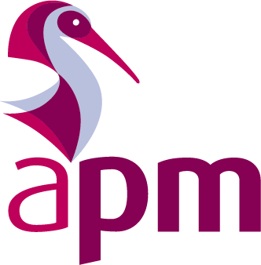
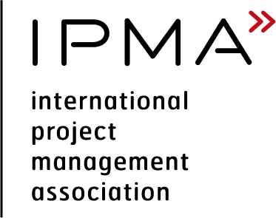
Candidate report

IPMA Level A: Certified Programme Director

Please complete the digital form and return by email.

Section 1: Your details

Your personal details
Title
First name
Surname
Name of organisation you work for
Name of training provider (if applicable)
Candidate number (if applicable)

Have you had assistance in completing your Report? (yes/no)

If yes, by whom?

Section 2: Information

Candidates submit a report covering their project(s), programme(s) and portfolio(s) based on the project(s), programme(s) and portfolio(s) listed on the application form and Executive Summary Report. The report describes the leadership of others in complex projects throughout the life cycle. This also applies to portfolio and programme management roles and life cycles (where applicable).
The Report is completed using the template structure below.
A maximum of 25 sides in A4 format are available for the report with additional 15 sides (maximum) for appendices.
The Report shall be produced with a font size of 11. Any appendices used shall be cross-referenced to the main body of the report.
The format of the Report should be such that it is possible to be emailed and read online. The Report should also be printable.

Section 3: Report
The Report must relate to a recently completed project(s) relevant to the level applied for. The data can be anonymised.
It is recommended that candidates use the STAR approach (Situation, Task, Action, Result) in order to structure the report if required.

Background
Background providing a detailed description of the project, role in context, key stakeholders and key objectives, project organisation and the associated resources the candidate is responsible for (maximum 3 sides of A4).

Management and leadership challenges
Description of the management and leadership challenges with respect to others, how these were acted upon and the results achieved and a reflection on these results and lessons learnt (maximum 3 sides of A4).

Assessment Criteria
Please explain how you have demonstrated each of the following assessment criteria below. Please refer to the appropriate syllabus. Your evidence should not exceed 1 side of A4 for each assessment criteria.
Unit 1 Learning outcome 1 Assessment criteria 1.1 and 1.2 (strategy)

Unit 1 Learning outcome 1 (4) (5) Assessment criteria 1.3, 4.1, 4.3 and 5.1 (governance structures and processes)

Unit 1 Learning outcome 1 Assessment criteria 1.4, 1.5 and 1.6 (compliance, standards and regulations)

Unit 1 Learning outcome 3(5) Assessment criteria 3.1, 3.2 and 5.2 (organisation and information)

Unit 1 Learning outcome 4 Assessment criteria 4.1, 4.4 and 4.5 (resources)

Unit 1 Learning outcome 4 Assessment criteria 4.2 and 4.3 (finance)

Unit 2 Learning outcome 5 Assessment criteria 5.1 and 5.2 (change and transformation)

Unit 3 Learning outcome 1 Assessment criteria 1.1 and 1.8 (benefits and objectives)

Unit 3 Learning outcome 1 Assessment criteria 1.2 and 1.3 (stakeholders)

Unit 3 Learning outcome 1 Assessment criteria 1.4, 1.5, 1.6 and 1.7 (programme design)

Unit 3 Learning outcome 2 Assessment criteria 2.1 and 2.2 (scope)

Unit 3 Learning outcome 2 Assessment criteria 2.3 and 3.3 (select and balance)

Unit 3 Learning outcome 2 Assessment criteria 2.4 and 2.5 (time)

Unit 3 Learning outcome 3 Assessment criteria 3.1 (quality)

Unit 3 Learning outcome 3(5) Assessment criteria 3.2, 3.3, 5.3 and 5.4 (plan and control)

Unit 3 Learning outcome 4 Assessment criteria 4.1, 4.2 and 4.3 (risk and opportunity)

Unit 3 Learning outcome 5 Assessment criteria 5.1 and 5.2 (procurement and partnership)

Section 4: Appendices
Cross-references plans, relevant company or project documents, minutes, reports etc. Please use font size 11. Maximum of 15 sides of A4 on a separate document.

Applicant checklist (check the box)

Completed ALL sections of your application

Completed forms to:

By email: ipmaqualifications@apm.org.uk
For queries regarding IPMA qualifications, or this application form, please contact the Qualifications Department: Tel: 01844 271680 Email: ipmaqualifications@apm.org.uk
Association for Project Management
Ibis House, Regent Park Tel. (UK) 0845 458 1944
Summerleys Road Tel. (UK) +44 1844 271 640
Princes Risborough E-mail ipmaqualifications@apm.org.uk
Buckinghamshire HP27 9LE Web apm.org.uk

Association for Project Management is incorporated
by Royal Charter RC000890 and a Registered Charity
No. 1171112. Principal office as shown above.

